**Output & Cost**

Marginal Product (MP) = $$\frac{Change in Total \operatorname{Pr}{o}duct }{Change in Labour}$$

Average Product (AP) = $$\frac{Total \operatorname{Pr}{o}duct}{Total Labour}$$

Total Cost (TC) = Fixed Cost (FC) + Variable Cost (VC)

Average Total Cost (ATC)= $$\frac{Total Cost}{Total \operatorname{Pr}{o}duct}$$

Marginal Cost (MC)= $$\frac{Change in Total Cost}{Change in Total \operatorname{Pr}{o}duct}$$

Average Fixed Cost (AFC)= $$\frac{Total Fixed Cost}{Total \operatorname{Pr}{o}duct}$$

Average Variable Cost (AVC)= $$\frac{Total Variable Cost}{Total \operatorname{Pr}{o}duct}$$

ATC=AFC + AVC

1. Table 1 shows how the quantity of cookies produced per hour at Caroline’s factory depends on the number of workers.

Calculate the missing data.

|  |  |  |  |  |  |  |  |  |  |
| --- | --- | --- | --- | --- | --- | --- | --- | --- | --- |
| Labour | Output | Marginal Product (MP) | Total Cost (TC) | Average Total Cost (ATC) | Marginal Cost (MC) | Total Fixed Cost (TFC) | Average Fixed Cost (AFC) | Total Variable Cost (TVC) | Average Variable Cost (AVC) |
| 0 | 0 |  | 30 |  |  | 30 |  |  |  |
| 1 | 50 |  |  |  |  |  |  | 10 |  |
| 2 | 90 |  |  |  |  |  |  |  |  |
| 3 | 120 |  |  |  |  |  |  |  |  |
| 4 | 140 |  |  |  |  |  |  |  |  |
| 5 | 150 |  |  |  |  |  |  |  |  |
| 6 | 155 |  |  |  |  |  |  | 60 |  |

1. Bill’s bakery has a fire and Bill loses some of his cost data. The bits of paper that he recovers after the fire provide the data in the following table (all the cost numbers are euros).

|  |  |  |  |  |
| --- | --- | --- | --- | --- |
| **TP** | **AFC** | **AVC** | **ATC** | **MC** |
| 10 | 120 | 100 | 220 | 0 |
| 20 | A | B | 150 | 80 |
| 30 | 40 | 90 | 130 | 90 |
| 40 | 30 | C | D | 130 |
| 50 | 24 | 108 | 132 | E |

Calculate the missing cost data identified as A, B, C, D and E from the table provided above.

**Perfect Competition**

Total Revenue (TR) = Price X Quantity

Average Revenue (AR) = $$\frac{Total Revenue}{Total \operatorname{Pr}{o}duct}$$

Marginal Revenue (MR) = $$\frac{Change in Total Revenue}{Change in Total \operatorname{Pr}{o}duct}$$

Profit= TR - TC

Profit Maximizing Quantity is found at the point where MR=MC

1. The table below shows the cost of production for upholstery fabric produced by Thomas Textiles. The fabric is sold in a perfectly competitive market.

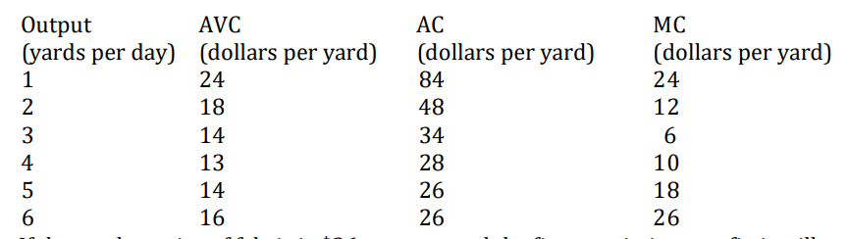

If the market price of fabric is $26 per year and the firm maximizes profit, how much output will it produce?

1. Consider total cost and total revenue given in the following table:

|  |  |  |  |  |  |
| --- | --- | --- | --- | --- | --- |
| Quantity | 0 | 1 | 2 | 3 | 4 |
| Total Cost | $8 | 9 | 10 | 11 | 13 |
| Total Revenue | $0 | 8 | 16 | 24 | 32 |

1. Calculate profit for each quantity. How much should the firm produce to maximize profit?
2. Calculate marginal revenue and marginal cost for each quantity.
3. Refer to the graph provided below:

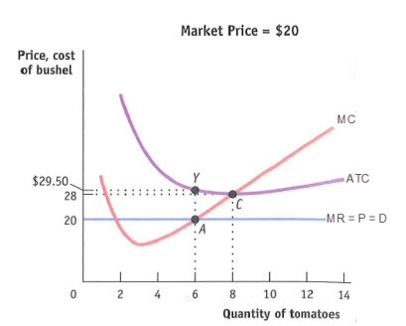

1. Assuming it is appropriate for the firm to produce in the short run, what is the firm’s profit-maximizing level of output?
2. Calculate the firm’s total revenue.
3. Calculate the firm’s total cost.
4. Calculate the firm’s profit or loss.
5. If AVC were $22 at the profit-maximizing level of output, would the firm produce in the short run? Explain why or why not.